|  |  |  |  |
| --- | --- | --- | --- |
| **Teacher** | **Day** | **Time** | **Contact\*** |
| Asst Prof Irena Aranđelović | Friday | 12:00 | Inst of Microbiology, Dr Subotića 1, ground floor  irena.arandjelovic@med.bg.ac.rs |
| Prof Valentina Arsić Arsenijević | Wednesday | 12:00 | Building Inst of Biochemistry, opposite entrance, ground floor; valentina.arsic-arsenijevic@med.bg.ac.rs |
| Assoc Prof Ana Banko | Wednesday | 12:00 | Inst of Microbiology, Dr Subotića 1, 2nd floor  ana.banko@med.bg.ac.rs |
| Prof Maja Ćupić | Tuesday | 10.00 | Inst of Microbiology, Dr Subotića 1, 1st floor  maja.cupic@med.bg.ac.rs |
| Assoc Prof Ivana Čolović Čalovski | Monday | 12:00 | Building Inst of Biochemistry, opposite entrance, ground floor; ivana.colovic-calovski@med.bg.ac.rs |
| Asst Prof Eleonora Dubljanin | Wednesday | 12:00 | Building Inst of Biochemistry, opposite entrance, ground floor; eleonora.dubljanin@med.bg.ac.rs |
| Prof Slobodanka Đukić | Tuesday | 9:00 | Inst of Microbiology, Dr Subotića 1, 1 floor  slobodanka.djukic@med.bg.ac.rs |
| Prof Aleksandar Džamić | Tuesday | 13:00 | Building Inst of Biochemistry, opposite entrance, ground floor; aleksandar.dzamic@med.bg.ac.rs |
| Asst Prof Ina Gajić | Thursday | 13:00 | Inst of Microbiology, Dr Subotića 1, ground floor  ina.gajic@med.bg.ac.rs |
| Prof Aleksandra Knežević | Tuesday | 14:00 | Inst of Microbiology, Dr Subotića 1, 1st floor  aleksandra.knezevic@med.bg.ac.rs |
| Prof Ivana Lazarević | Monday | 12:00 | Inst of Microbiology, Dr Subotića 1, 2nd floor  ivana.lazarevic@med.bg.ac.rs |
| Assoc Prof Vera Mijač | Monday | 12:00 | Inst of Microbiology, Dr Subotića 1, ground floor  vera.mijac@med.bg.ac.rs |
| Asst Prof Danijela Miljanović | Monday | 9:00 | Inst of Microbiology, Dr Subotića 1, 2nd floor  danijela.miljanovic@med.bg.ac.rs |
| Prof Nataša Vučković Opavski | Tuesday | 11:30 | Inst of Microbiology, Dr Subotića 1, 1st fl@oor  natasa.vuckovic-opavski@med.bg.ac.rs |
| Prof Maja Stanojević | Monday | 14:00 | Inst of Microbiology, Dr Subotića 1, 2nd floor  maja.stanojevic@med.bg.ac.rs |
| Prof Dragana Vuković | Tuesday | 14:00 | Inst of Microbiology, Dr Subotića 1, ground floor  dragana.vukovic@med.bg.ac.rs |

*Please, contact teacher by e-mail in advance.

Course Director Belgrade, March 15, 2021

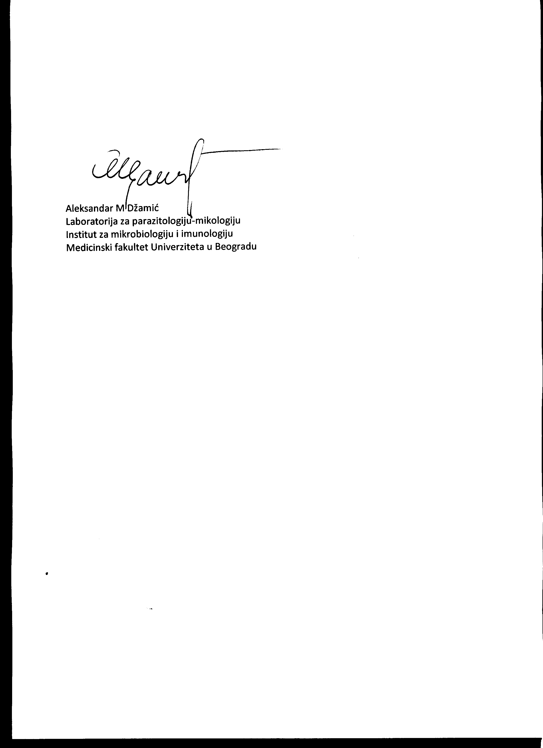

Aleksandar M Džamić

**University of Belgrade Faculty of Medicine**

**Department of Medical and Clinical Microbiology**

Dear students,

During summer semester 2023, student short consultations with teachers are possible.

The consultations are organized in direct way in the scheduled time, which you can find in the table for every teacher.

The consultations refer to all areas of Medical Microbiology, they are informative and refer to general remarks, which are the most important things regarding a certain methodological unit, as well as brief explanation of unclear facts.

Your preparation for the consultation involves specific and clear questions!

The consultation lasts up to 20 minutes, in one term per week (max two students), with all protective measures against COVID-19.

Please contact teacher in advance by e-mail.

Best, Belgrade, March 15, 2023



Aleksandar Džamić